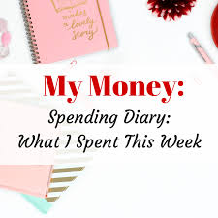

Spending Diary

Why should I fill out a spending diary?
Now that you have taken the important decision to start budgeting, the best way to begin is by recording all your spending.
A spending diary can be as simple as a piece of paper where you write down everything (no matter how small) you spend your money on e.g. packet of chewing gum, coffee, drink etc to a spreadsheet you have created.
If you want to control your money, your first need to know where it goes – a spending diary goes hand in hand with a budget planner.

Date | Description | Type (cash/debit/cheque) | Amount | Did I need it (N),  did I want it (W).
1st Sept | Diet Coke | Cash |  | W
1st Sept | Weekly food shop | Debit |  | N
1st Sept | Muffin (bought on campus) | Cash |  | W
1st Sept | Cappuccino (bought on campus) | Cash |  | W
1st Sept | Bus fare | Cash |  | W
1st Sept | Packet chewing gum | Cash |  | W
1st Sept | 3 beers pints | Cash |  | W
1st Sept | Packet of crisps | Cash |  | W
1st Sept | Portion of chips | Cash |  | W

Total essential (needed) cost _________
Total non-essential (wanted) cost _________
Total costs €

Have a go at creating your own spending diary to keep track of where your money goes:

Date | Description | Type  (Cash/Debit) | Amount | Did I need it (N) Did I want it (W)

